Chapter 6, Solution 30.

v_{o =} 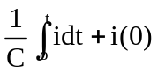
For 0 < t < 1, i = 90t mA,
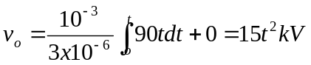
v_{o}(1) = 15 kV

For 1< t < 2, i = (180 – 90t) mA,
v_{o} = 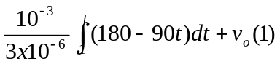
= [60t – 15t²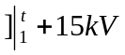
= [60t – 15t² – (60–15) + 15] kV = [60t – 15t² – 30] kV

